**PROJECT REPORT**

Ola Taxi Ride Analysis

**Name** – Abhishek Satpute

**Project Title** – Ola Taxi Ride

**Date** – 13 Jan 2025

**Technology** – Power Bi

**Tools-** Power BI Visualization Tools

**1. Project Description**

The OLA Taxi Ride Analysis project aims to provide insights into the performance of taxi services based on various key parameters, such as revenue, bookings, and customer ratings. This report is based on data visualization from an interactive dashboard displaying key metrics and trends. The primary goal of this project is to help stakeholders understand the underlying patterns in ride bookings and revenue generation, enabling data-driven decision-making.

**2. Objectives**

The objectives of this analysis are:

* To analyze monthly revenue trends and identify peak periods.
* To evaluate gender-based booking preferences.
* To identify the primary reasons for bookings.
* To track the volume of bookings over time.
* To assess customer ratings and identify areas of improvement.
* To explore booking patterns by time of the day and day of the week.
* To provide actionable insights and recommendations for improving service quality and revenue.

**3. Key Performance Indicators (KPIs)**



The following KPIs have been identified for this analysis:

* Total number of bookings.
* Total revenue.
* Average customer rating.
* Total toll expenses.
* Driver base cost.
* Monthly revenue trend.

**4. Data Summary**

* Total Bookings: 4950
* Total Revenue: 1.30 million
* Average Rating: 3.73
* Total Toll: 27,000
* Driver Base Cost: 971,000

**5. Analysis and Findings**

a. Monthly Revenue

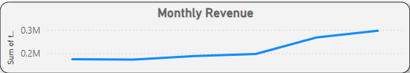

* The monthly revenue shows a consistent upward trend.
* There is a noticeable increase in revenue during the later months, with June recording the highest revenue.

b. Bookings by Gender

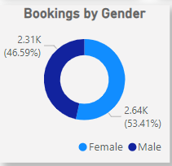

* Female customers accounted for 46.59% of the bookings, while male customers accounted for 53.41%.
* The difference in gender-based bookings is minimal, indicating a balanced customer base.

c. Bookings by Reason

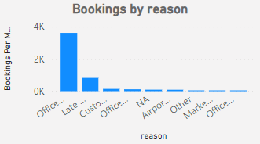

* The primary reason for bookings is "Office," accounting for the highest number of rides.
* Other significant reasons include late pickups and customer-specific requests.

d. Count of Booking IDs by Month

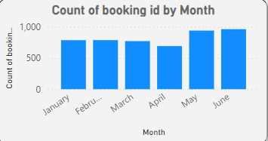

* The volume of bookings increased steadily from January to June.
* June recorded the highest number of bookings, indicating a peak period in service demand.

e. Bookings by Ratings

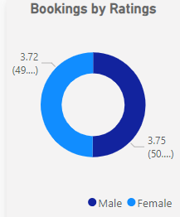

* The average rating of bookings is 3.73.
* Ratings are almost equally distributed between male and female customers, with slight variations in averages.

f. Bookings by Time of the Day

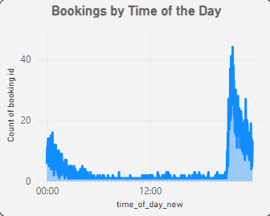

* The highest number of bookings occurs in the evening, around 6 PM to 8 PM.
* There is a lower volume of bookings during early morning hours, indicating reduced demand at that time.

g. Bookings by Day of the Week

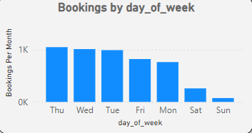

* The highest number of bookings occurs on weekdays, especially from Tuesday to Thursday.
* Weekends (Saturday and Sunday) have the lowest number of bookings, indicating reduced demand.

**6. Observations**

1. Monthly Revenue Growth: There is a clear upward trend in monthly revenue, suggesting an increase in customer demand over time.
2. Balanced Gender Distribution: The near-equal distribution of bookings by gender indicates that the service is equally popular among male and female customers.
3. Office-related Rides Dominant: A significant proportion of bookings are for office commutes, indicating that the service is primarily used for work-related travel.
4. Evening Peak Hours: The highest demand is observed during evening hours, likely due to office commute and personal errands.
5. Weekday Dominance: The majority of bookings occur on weekdays, with a sharp decline during weekends.

**7. Dashboard Snapchat**

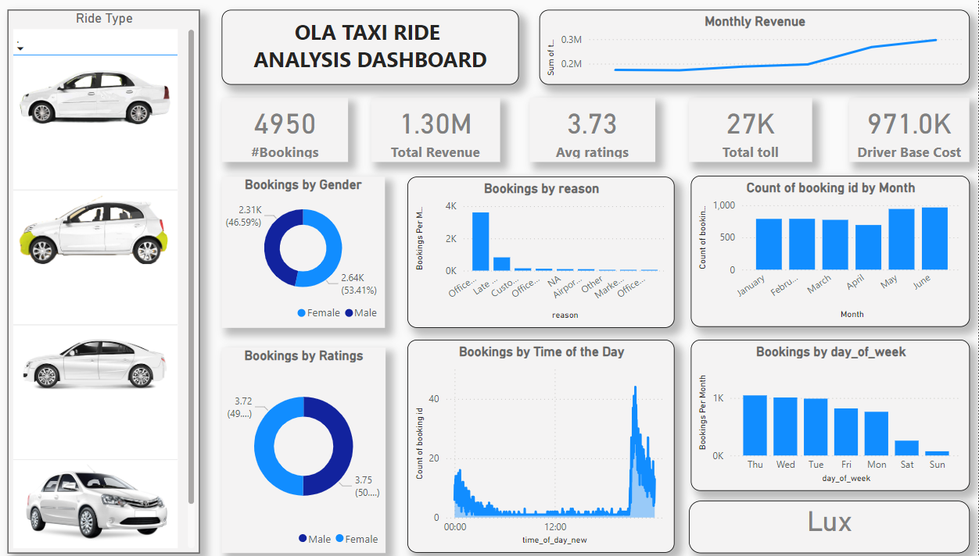

**8. Recommendations**

* Promotional Campaigns for Weekends: Introduce discounts and promotions for weekend rides to boost demand during low-traffic days.
* Targeted Marketing for Office Commutes: Since office-related travel is a major reason for bookings, targeted promotions and partnerships with corporate clients can increase revenue.
* Improvement in Ratings: Focus on improving customer service to raise the average rating above 4. This can be achieved through driver training, better ride comfort, and reduced wait times.
* Incentives for Off-peak Hours: Offer special incentives for rides during off-peak hours (early morning and late night) to balance demand throughout the day.

**9. Conclusion**

The OLA Taxi Ride Analysis has provided valuable insights into the service's performance over six months. The upward trend in revenue and the balanced customer base are positive indicators for the business. By addressing the areas of improvement highlighted in the report, OLA can further enhance customer satisfaction, increase bookings, and boost overall profitability.